Git Best Practices

## **Commit Message Guidelines**

1. Capitalized summary should be less than 50 characters and it should not end with period(.)
2. Always leave the second line blank
3. Write your commit message in the imperative: "Fix bug" and not "Fixed bug" or "Fixes bug." For example, fix, refactor (**when comments given by reviewer**), add, and remove
4. Further paragraphs come after blank lines, and it should be in detail. Bullet points are okay, too. Typically, a hyphen or asterisk is used for the bullet, preceded by a single space, with blank lines in between
5. Make sure summary or details message should not have space at the tail.
6. Use Signature at the end of the message with one preceding blank line. In case of Gitbash editor (**CTRL + S**). Most recent editor does have inbuilt signature configured while cloning the git branch.

Underneath is the example of git commit message

**Fix issue with login button not** **showing <---- Summary**  
 **<---- Blank line**  
 - update login form validation **<---- Descriptive message**  
 - update login styling for showing the button **<---- Descriptive message**

References:

1. [**https://gist.github.com/robertpainsi/b632364184e70900af4ab688decf6f53**](https://gist.github.com/robertpainsi/b632364184e70900af4ab688decf6f53)

## **Git Branch Guidelines**

1. Ideally three branches are there those are as below:
   1. Master
   2. Staging
   3. Development
2. Master branch:
   1. This is the production code branch.
   2. Only Hot Fix are applied
   3. Merge and re-merge are only between staging to master.
3. Staging branch:
   1. This is the intermediate branch between production (master) and development branch.
   2. Used for UAT environment as well.
   3. Merge and re-merge are only between staging to development.
   4. Development branch fork from staging branch.
4. Development branch:
   1. Developer branch only for development.
   2. Subbranches like **Feature – Id**, **Bug – Id** fork from the development branch.
   3. Merge and re-merge are only between development to subbranches.
5. Git branch Workflow diagram (**Consider UAT as Staging branch as shown in diagram**)

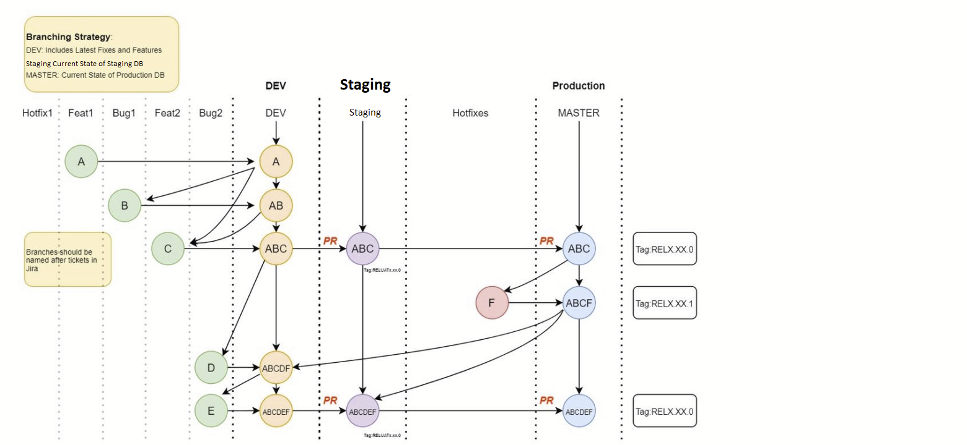

## **General Git Guidelines**

References:

1. [**https://gist.github.com/luismts/495d982e8c5b1a0ced4a57cf3d93cf60**](https://gist.github.com/luismts/495d982e8c5b1a0ced4a57cf3d93cf60)

## **Developer Best Practice Guidelines**

1. Before doing development **TAKE GIT PULL** to have the latest copy of the project.
2. After development is completed **TAKE GIT PULL ATLEAST 2 TIMES** before pushing code to the forked branch.